Beacon Tradeport

Community Development District

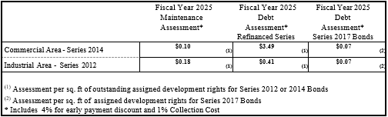

*Represents Fiscal Year 2024-2025
(October 1, 2024 through September 30, 2025)

